**Project 1 : Led blinking**

**Purpose:**

• Traditionally, introductory programs in many programming languages output the phrase "hello world" to the screen.

• In the context of Arduino, where there is no screen, a common alternative is to create a program that blinks an LED.

• LEDs, being diodes, have polarity, requiring correct leg orientation for illumination. The longer leg is usually positive and should be connected to pin 13.

• Conversely, the shorter leg connects to GND, and often the bulb of the LED has a flat edge indicating this side.

**Requirements-**

|  |  |
| --- | --- |
|  | 1. Ardunio Uno 2. LED 3. Resistor 4. Jumper Wire 5. Bread Board |

**Procedure-**

* 1. Download & install the Arduino environment (IDE)
  2. Connect the board to your computer via the UBS cable
  3. If needed, install the drivers (not needed in lab)
  4. Launch the Arduino IDE
  5. Select your board
  6. Select your serial port
  7. Open the blink example
  8. Upload the program

**Try It: Connect the USB Cable**

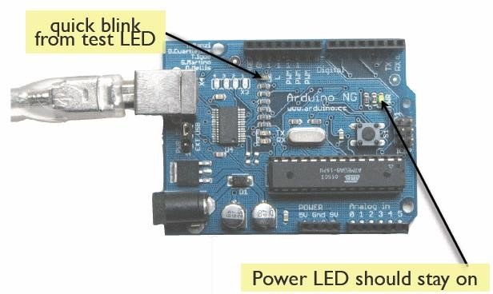

**Let’s start programming   
Blink a led !!!**

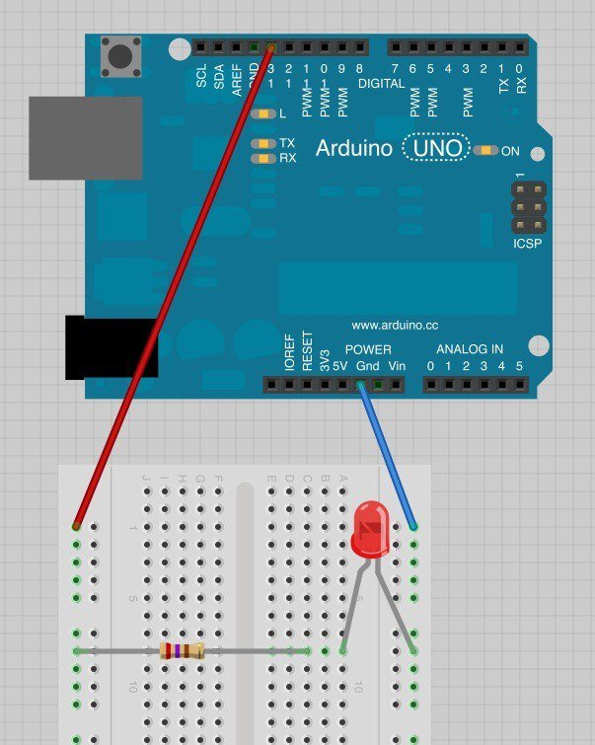

**Our First Program:**

*(For Code Scan The QR Code)*

// the setup function runs once when you press reset or power the board

int led=13;

void setup() {

// initialize digital pin LED_BUILTIN as an output. As Ardunio Has Internally connected in LED in Digital pin 13.

pinMode(led, OUTPUT);

}

// the loop function runs over and over again forever

void loop() {

digitalWrite(led, HIGH); // turn the LED on (HIGH is the voltage level)

delay(1000); // wait for a second

digitalWrite(led, LOW); // turn the LED off by making the voltage LOW

delay(1000); // wait for a second

}

**Project 2 : Led looping**

**Purpose**

* Often you want to iterate over a series of pins and do something to each one.
* For instance, this example blinks 6 LEDs attached to the Arduino by using a [for()](https://www.arduino.cc/en/Reference/For) loop to cycle back and forth through digital pins

2-7. The LEDS are turned on and off, in sequence, by using both the [digitalWrite()](https://www.arduino.cc/en/Reference/DigitalWrite) and [delay()](https://www.arduino.cc/en/Reference/Delay) functions

**Requirements**

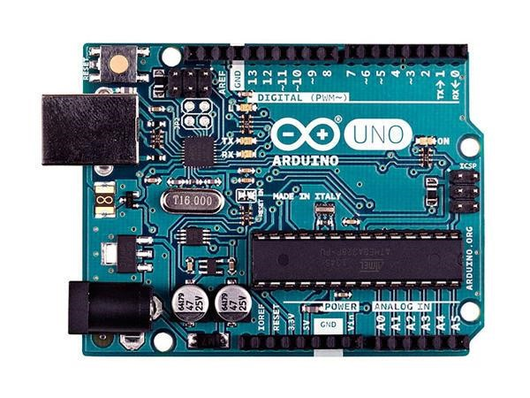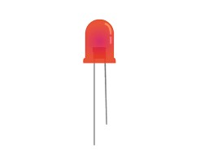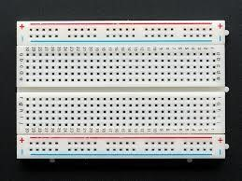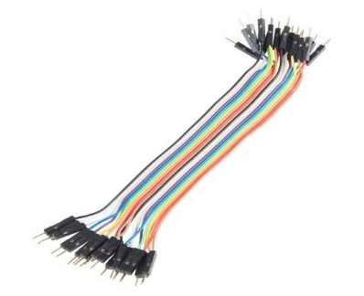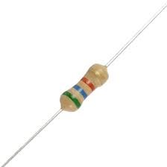

**Let’s start LED looping**

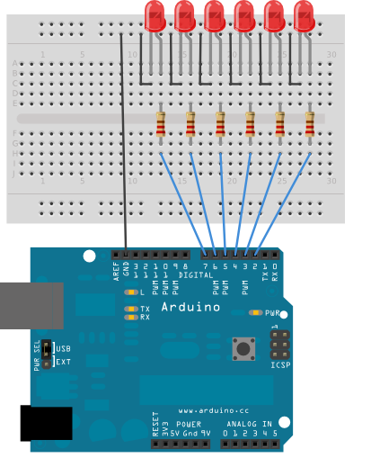

***For Code Scan The QR Code***

**Home Task-**

1. **Please Blink LED 7 to LED 2**

**Blink all , then off all using delay .5 Second**